**Threshold Autoregressive Models — beyond ARIMA + R Code**

**Meet TAR — a nonlinear extension of the autoregressive model.**

**Introduction**

When it comes to time series analysis, academically you will most likely start with Autoregressive models, then expand to Autoregressive Moving Average models, and then expand it to integration making it ARIMA. The next steps are usually types of seasonality analysis, containing additional endogenous and exogenous variables (ARDL, VAR) eventually facing cointegration. *And from this moment on things start getting really interesting*.

That’s because it’s the end of strict and beautiful procedures as in e.g. Box-Jenkins methodology. [As explained before, the possible number of permutations of nonlinearities in time series is nearly infinite](https://medium.com/@michacukrowski/nonlinear-time-series-an-intuitive-introduction-7390aae8b446) — so universal procedures don’t hold anymore. Does it mean that the game is over? Hell, no! Today, the most popular approach to dealing with nonlinear time series is using machine learning and deep learning techniques — since we don’t know the true relationship between the moment *t-1* and *t*, we will use an algorithm that doesn’t assume types of dependency.

How did econometricians manage this problem *before* machine learning? That’s where the TAR model comes in.

**Threshold Autoregressive Models**

Let us begin with the simple AR model. Its formula is determined as:

Everything is in only one equation — beautiful. Before we move on to the analytical formula of TAR, I need to tell you about how it actually works. First of all, in TAR models there’s something we call *regimes*. What are they? They are regions separated by the *thresholds* according to which we switch the AR equations. *We switch, what?* Let’s consider the simplest two-regime TAR model for simplicity:

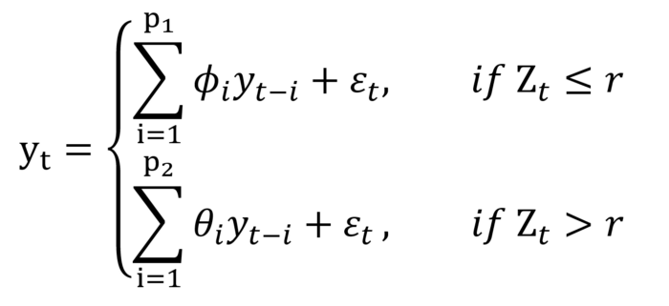

Generic equation of Threshold Autoregressive, graphics by author.

Where:

p1, p2 — the order of autoregressive sub-equations,

r — the known threshold value,

Z\_t — the known value in the moment *t* on which depends the regime

Let’s read this formula now so that we understand it better:

The value of the time series in the moment *t* is equal to the output of the autoregressive model, which fulfils the *condition:* ***Z ≤ r*** *or* Z *> r.*

Sounds kind of abstract, right? No wonder — the TAR model is a generalisation of threshold switching models. **It means you’re the most flexible when it comes to modelling the conditions, under which the regime-switching takes place.** I recommend you read this part again once you read the whole article — I promise it will be more clear then. Now, let’s move to a more practical example.

If we put *the previous values* of the time series in place of the Z\_t value, a TAR model becomes a Self-Exciting Threshold Autoregressive model — SETAR(k, p1, …, pn), where *k* is the number of regimes in the model and *p* is the order of every autoregressive component consecutively. A two-regimes SETAR(2, p1, p2) model can be described by:

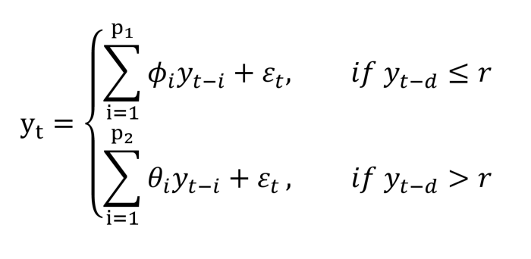

Generic equation of two-regimes SETAR, graphics by author.

Now it seems a bit more earthbound, right? Let’s visualise it with a scatter plot so that you get the intuition:

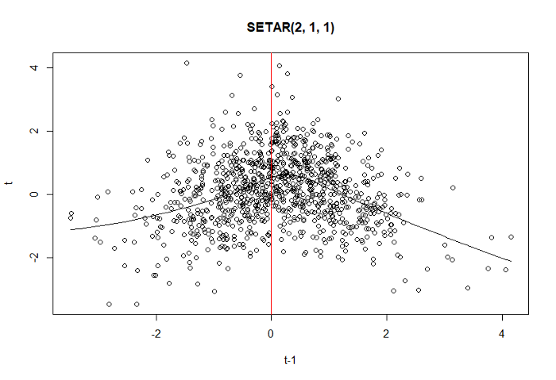

Scatter plot for a generated SETAR(2, 1, 1) with a LOESS line plotted on it and a vertical red line marking the threshold, graphic by author. (generated with tsDyn)

In this case, k = 2, r = 0, p1 = p2 = 1 and d = 1*.* You can clearly see the threshold where the regime-switching takes place. How does it look on the actual time series though?

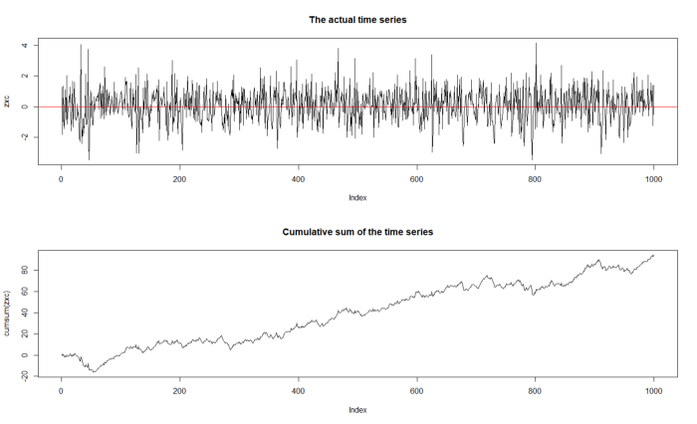

Generated SETAR(2, 1, 1) and its cumulative sum, graphic by author.

As you can see, it’s very difficult to say just from the look that we’re dealing with a threshold time series just from the look of it. What can we do then? Let’s solve an example that is not generated so that you can repeat the whole procedure.

**Modelling procedure**

Let’s just start coding, I will explain the procedure along the way. We are going to use the Lynx dataset and divide it into training and testing sets (we are going to do forecasting):

library("quantmod")  
library("tsDyn")  
library("stats")  
library("nonlinearTseries")  
library("datasets")  
library("NTS")  
  
data <- log10(datasets::lynx)  
  
train <- data[1:80]  
test <- data[81:114]

I logged the whole dataset, so we can get better statistical properties of the whole dataset. Now, let’s check the autocorrelation and partial autocorrelation:

{par(mfrow=c(2,1))  
acf(train)  
pacf(train)}

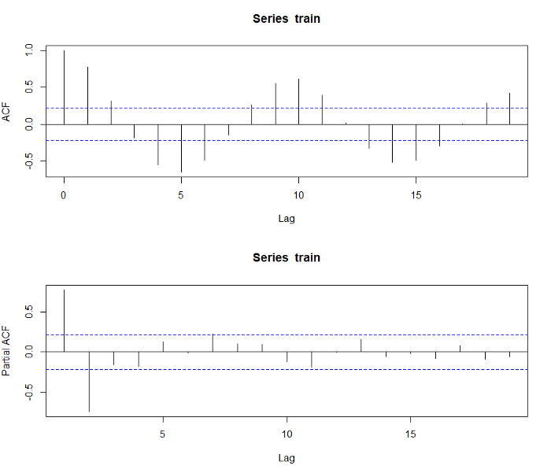

By Author

It seems like this series is possible to be modelled with ARIMA — will try it on the way as well. Nevertheless, let’s take a look at the lag plots:

{par(mfrow=c(2,2))  
 scatter.smooth(Lag(train, 1), train, span = 2/3, degree = 1,  
 family = c("symmetric", "gaussian"), evaluation = 50,   
 xlab = "t-1", ylab = "t")  
 scatter.smooth(Lag(train, 2), train, span = 2/3, degree = 1,  
 family = c("symmetric", "gaussian"), evaluation = 50,   
 xlab = "t-2", ylab = "t")  
 scatter.smooth(Lag(train, 3), train, span = 2/3, degree = 1,  
 family = c("symmetric", "gaussian"), evaluation = 50,   
 xlab = "t-3", ylab = "t")  
 scatter.smooth(Lag(train, 4), train, span = 2/3, degree = 1,  
 family = c("symmetric", "gaussian"), evaluation = 50,   
 xlab = "t-4", ylab = "t")  
}

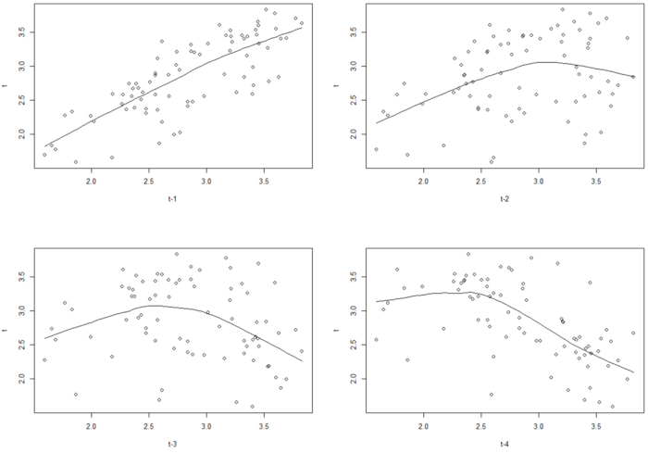

Scatter plots for lags of the training set with LOESS line on, by Author

In the first lag, the relationship does seem fit for ARIMA, but from the second lag on nonlinear relationship is obvious. Sometimes however it happens so, that it’s not *that* simple to decide whether this type of nonlinearity is present. In this case, we’d have to run a statistical test — this approach is the most recommended by both Hansen’s and Tsay’s procedures. In order to do it, however, it’s good to first establish what lag order we are more or less talking about. We will use Average Mutual Information for this, and we will limit the order to its first local minimum:

mutualInformation(train)

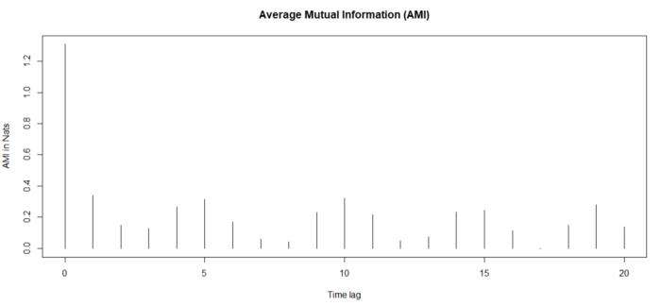

AMI for the training set, by Author

Thus, the embedding dimension is set to *m=3*. Of course, this is only one way of doing this, you can do it differently. Note, that again we can see strong seasonality. Now, that we’ve established the maximum lag, let’s perform the statistical test. We are going to use the Likelihood Ratio test for threshold nonlinearity. Its hypotheses are:

H0: The process is an AR(p)

H1: The process is a SETAR(p, d)

This means we want to reject the null hypothesis about the process being an AR(p) — but remember that the process should be autocorrelated — otherwise, the H0 might not make much sense.

for (d in 1:3){  
 for (p in 1:3){  
 cat("p = ", p, " d = ", d, " P-value = ", thr.test(train, p=p, d=d), "\n")  
 }  
}

SETAR model is entertained   
Threshold nonlinearity test for (p,d): 1 1   
F-ratio and p-value: 0.5212731 0.59806   
  
SETAR model is entertained   
Threshold nonlinearity test for (p,d): 2 1   
F-ratio and p-value: 2.240426 0.1007763   
  
SETAR model is entertained   
Threshold nonlinearity test for (p,d): 3 1   
F-ratio and p-value: 1.978699 0.1207424   
  
SETAR model is entertained   
Threshold nonlinearity test for (p,d): 1 2   
F-ratio and p-value: 37.44167 1.606391e-09   
  
SETAR model is entertained   
Threshold nonlinearity test for (p,d): 2 2   
F-ratio and p-value: 8.234537 0.0002808383   
  
SETAR model is entertained   
Threshold nonlinearity test for (p,d): 3 2   
F-ratio and p-value: 7.063951 0.0003181314   
  
SETAR model is entertained   
Threshold nonlinearity test for (p,d): 1 3   
F-ratio and p-value: 30.72234 1.978433e-08   
  
SETAR model is entertained   
Threshold nonlinearity test for (p,d): 2 3   
F-ratio and p-value: 3.369506 0.02961576   
  
SETAR model is entertained   
Threshold nonlinearity test for (p,d): 3 3   
F-ratio and p-value: 3.842919 0.01135399

As you can see, at alpha = 0.05we cannot reject the null hypothesis only with parameters d = 1, but if you come back to look at the lag plots you will understand why it happened.

Another test that you can run is Hansen’s linearity test. Its hypotheses are:

H0: The time series follows some AR process

H1: The time series follows some SETAR process

This time, however, the hypotheses are specified a little bit better — we can test AR vs. SETAR(2), AR vs. SETAR(3) and even SETAR(2) vs SETAR(3)! Let’s test our dataset then:

setarTest(train, m=3, nboot=400)  
setarTest(train, m=3, nboot=400, test='2vs3')

Test of linearity against setar(2) and setar(3)  
  
 Test Pval  
1vs2 25.98480 0.0175  
1vs3 46.31897 0.0150  
  
  
Test of setar(2) against setar(3)  
  
 Test Pval  
2vs3 15.20351 0.2425

This test is based on the bootstrap distribution, therefore the computations might get a little slow — don’t give up, your computer didn’t die, it needs time :) In the first case, we can reject both nulls — the time series follows either SETAR(2) or SETAR(3). From the second test, we figure out we cannot reject the null of SETAR(2) — therefore there is no basis to suspect the existence of SETAR(3). Therefore SETAR(2, p1, p2) is the model to be estimated.

So far we have estimated *possible ranges* for *m*, *d* and the value of *k.* What is still necessary is the threshold value *r*. Unfortunately, its estimation is the most tricky one and has been a real pain in the neck of econometricians for decades. I do not know about any analytical way of computing it (if you do, let me know in the comments!), instead, usually, grid-search is performed.

The intuition behind is a little bit similar to Recursive Binary Splitting in decision trees — we estimate models continuously with an increasing threshold value. Fortunately, we don’t have to code it from 0, that feature is available in R. Before we do it however I’m going to explain shortly what you should pay attention to.

We want to achieve *the smallest possible information criterion value for the given threshold value*. Nevertheless, this methodology will always give you some output! What you are looking for is a **clear minimum**. This is what would look good:

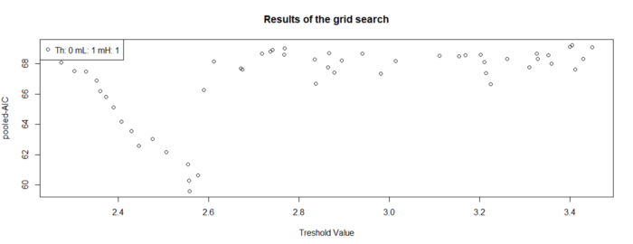

Grid search for tsDyn generated dataset

There is a *clear* minimum a little bit below 2.6. The more V-shaped the chart is, the better — but it’s not like you will always get a beautiful result, therefore the interpretation and lag plots are crucial for your inference. This is what does *not* look good:

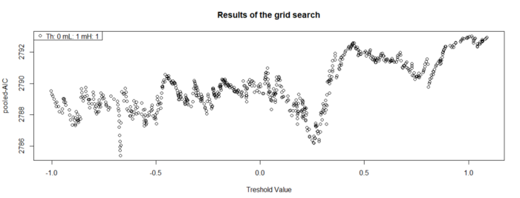

Grid search for R generated dataset

Whereas this one also has some local minima, it’s not as apparent as it was before — letting SETAR take this threshold you’re risking overfitting. In practice though it never looks so nice — you’re searching for many combinations, therefore there will be many lines like this. Let’s get back to our example:

selectSETAR(train, m=3, thDelay=1:2)

Using maximum autoregressive order for low regime: mL = 3   
Using maximum autoregressive order for high regime: mH = 3   
Searching on 50 possible threshold values within regimes with sufficient ( 15% ) number of observations  
Searching on 900 combinations of thresholds ( 50 ), thDelay ( 2 ), mL ( 3 ) and MM ( 3 )   
Results of the grid search for 1 threshold  
 thDelay mL mH th pooled-AIC  
1 2 3 3 2.940018 -26.88059  
2 2 3 3 2.980912 -26.44335  
3 2 3 2 2.940018 -24.66521  
4 2 3 2 2.980912 -24.43568  
5 2 3 3 2.894316 -24.20612  
6 2 3 3 3.399847 -22.98202  
7 2 3 2 2.894316 -22.89391  
8 2 2 3 2.940018 -22.15513  
9 2 3 2 3.399847 -21.34704  
10 2 1 3 2.940018 -20.52942

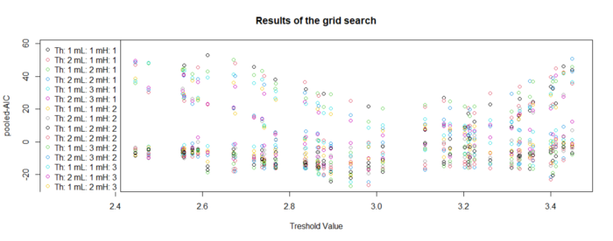

Grid search for the training set

Therefore the preferred coefficients are:

thDelay mL mH th pooled-AIC  
2 3 3 2.940018 -26.88059

Great! It’s time for the final model estimation:

model <- setar(train, m=3, thDelay = 2, th=2.940018)  
summary(model)

Non linear autoregressive model  
  
SETAR model ( 2 regimes)  
Coefficients:  
Low regime:  
 const.L phiL.1 phiL.2 phiL.3   
 0.8765919 0.9752136 0.0209953 -0.2520500   
  
High regime:  
 const.H phiH.1 phiH.2 phiH.3   
 0.3115240 1.6467881 -1.3961317 0.5914694   
  
Threshold:  
-Variable: Z(t) = + (0) X(t)+ (0)X(t-1)+ (1)X(t-2)  
-Value: 2.94 (fixed)  
Proportion of points in low regime: 55.84% High regime: 44.16%   
  
Residuals:  
 Min 1Q Median 3Q Max   
-0.5291117 -0.1243479 -0.0062972 0.1211793 0.4866163   
  
Fit:  
residuals variance = 0.03438, AIC = -254, MAPE = 5.724%  
  
Coefficient(s):  
  
 Estimate Std. Error t value Pr(>|t|)   
const.L 0.876592 0.227234 3.8577 0.0002469 \*\*\*  
phiL.1 0.975214 0.142437 6.8466 2.117e-09 \*\*\*  
phiL.2 0.020995 0.196830 0.1067 0.9153498   
phiL.3 -0.252050 0.121473 -2.0749 0.0415656 \*   
const.H 0.311524 0.685169 0.4547 0.6507163   
phiH.1 1.646788 0.172511 9.5460 2.027e-14 \*\*\*  
phiH.2 -1.396132 0.277983 -5.0224 3.576e-06 \*\*\*  
phiH.3 0.591469 0.272729 2.1687 0.0334088 \*   
---  
Signif. codes: 0 ‘\*\*\*’ 0.001 ‘\*\*’ 0.01 ‘\*’ 0.05 ‘.’ 0.1 ‘ ’ 1  
  
Threshold  
Variable: Z(t) = + (0) X(t) + (0) X(t-1)+ (1) X(t-2)  
  
Value: 2.94 (fixed)

SETAR model has been fitted. Now, since we’re doing forecasting, let’s compare it to an ARIMA model (fit by auto-arima):

ARIMA(4,0,1) with non-zero mean   
  
Coefficients:  
 ar1 ar2 ar3 ar4 ma1 mean  
 0.3636 0.4636 -0.4436 -0.2812 0.9334 2.8461  
s.e. 0.1147 0.1290 0.1197 0.1081 0.0596 0.0515  
  
sigma^2 = 0.0484: log likelihood = 8.97  
AIC=-3.93 AICc=-2.38 BIC=12.74  
  
Training set error measures:  
 ME RMSE MAE MPE MAPE MASE  
Training set -0.0002735047 0.2115859 0.1732282 -0.6736612 6.513606 0.5642003  
 ACF1  
Training set -0.002296863

SETAR seems to fit way better on the training set. Now let’s compare the results with MSE and RMSE for the testing set:

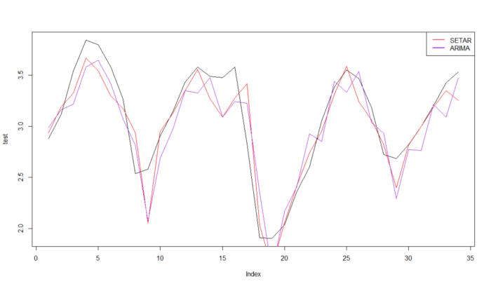

Predictions out-of-sample with SETAR and ARIMA, by Author

SETAR MSE: 0.04988592  
SETAR RMSE: 0.2233516  
  
ARIMA MSE: 0.06146426  
ARIMA RMSE: 0.2479199

As you can see, SETAR was able to give better results for both training and testing sets.

**Final notes**

1. Stationarity of TAR — this is a very complex topic and I strongly advise you to look for information about it in scientific sources. Nevertheless, there is an incomplete rule you can apply: **If there is a unit root in any of the regimes, the whole process is nonstationary**.
2. The first generated model was stationary, but TAR can model also nonstationary time series under some conditions. It’s safe to do it when its regimes are all stationary. In this case, you will most likely be dealing with structural change.
3. The number of regimes — in theory, the number of regimes is not limited anyhow, however from my experience I can tell you that if the number of regimes exceeds 2 it’s usually better to use machine learning.
4. **SETAR model is very often confused with TAR** — don’t be surprised if you see a TAR model in a statistical package that is actually a SETAR. Every SETAR is a TAR, but not every TAR is a SETAR.
5. To fit the models I used AIC and pooled-AIC (for SETAR). If your case requires different measures, you can easily change the information criteria.

**Summary**

Threshold Autoregressive models used to be the most popular nonlinear models in the past, but today substituted mostly with machine learning algorithms. Nonetheless, they have proven useful for many years and since you always choose the tool for the task, I hope you will find it useful.

Of course, SETAR is a basic model that can be extended. If you are interested in getting even better results, make sure you follow my [profile](https://medium.com/@michacukrowski)!

You can also reach me on [LinkedIn](https://www.linkedin.com/in/micha%C5%82-cukrowski/).

[Link](https://www.picostat.com/dataset/r-dataset-package-datasets-lynx) to the data (GNU).

**[Nonlinear Time Series — an intuitive introduction](https://towardsdatascience.com/nonlinear-time-series-an-intuitive-introduction-7390aae8b446" \t "_blank)**

**[Why do your standard time series analysis procedures sometimes fail?](https://towardsdatascience.com/nonlinear-time-series-an-intuitive-introduction-7390aae8b446" \t "_blank)**

[towardsdatascience.com](https://towardsdatascience.com/nonlinear-time-series-an-intuitive-introduction-7390aae8b446" \t "_blank)

Thanks to Ben Huberman